Q1.
Answer is A.

A: Correct. This is standard SQL syntax and works in Oracle.
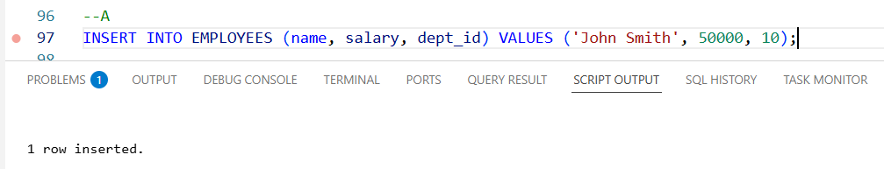

B: Incorrect. This is MySQL-specific syntax, not standard SQL or Oracle.
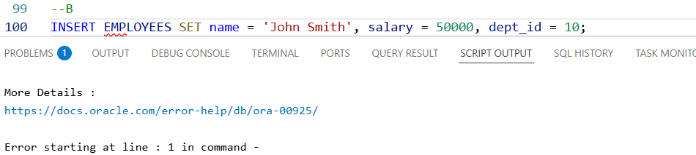

C: Incorrect. This works only if EMPLOYEES has exactly three columns in this order.
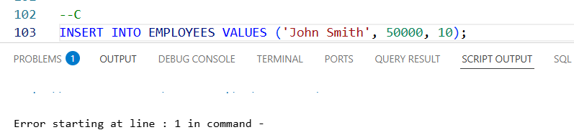

D: Incorrect. Invalid SQL syntax.
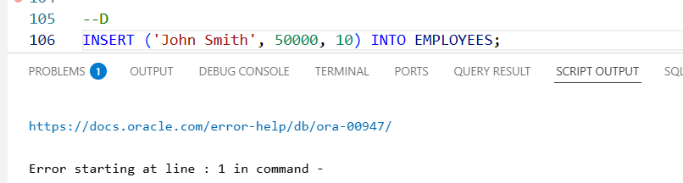

Q2.
Answer is Both A and C. A uses days, C uses months.

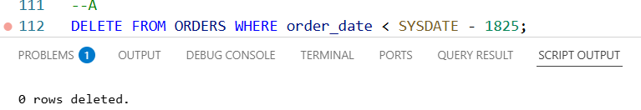

A: Correct. DELETE FROM ORDERS WHERE order_date < SYSDATE - 1825 will delete all orders older than 5 years.

B: Also Correct. Work but not standard.

C: Also Correct.

D: Incorrect. DELETE * is invalid.

Q3.
Answer is A.

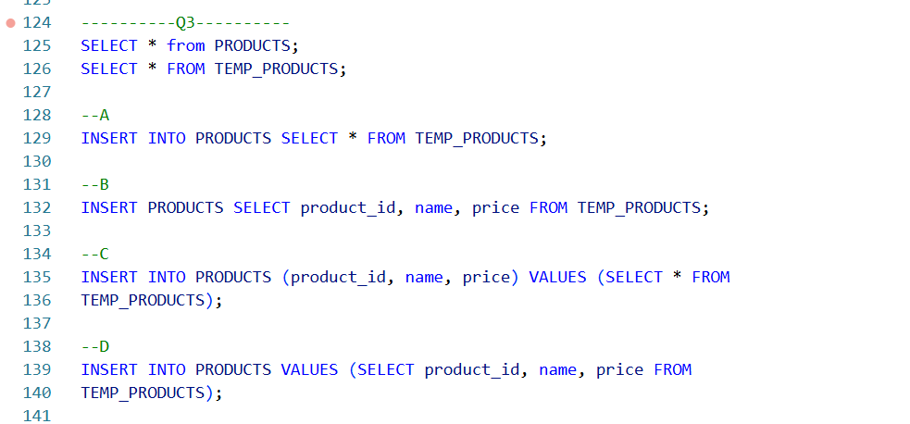

A: Correct. It copies all rows from TEMP_PRODUCTS into PRODUCTS.

B: Incorrect. The statement is missing the keyword INTO. Without INTO, Oracle will throw a syntax error.

C: Incorrect. Oracle will return an error because VALUES does not accept a subquery that returns multiple rows.

D: Incorrect. The Syntax is not valid. VALUES cannot take a SELECT query.

Q4.
Answer is B.

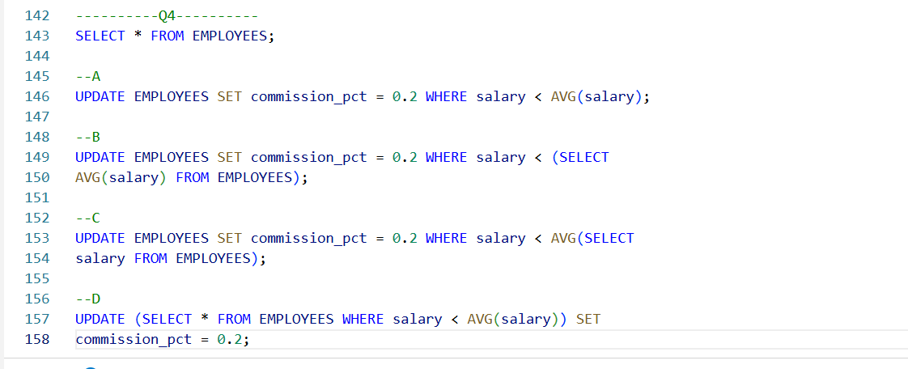

A: Incorrect. You must use a subquery, not AVG(salary) directly.

B: Correct. The average must be calculated using a subquery, not a direct aggregate function in the WHERE clause.

C: Incorrect. The syntax is invalid.

D: Incorrect. You cannot use an aggregate function AVG(salary) inside the WHERE clause of an inline view like this.

Q5.
Answer is C.

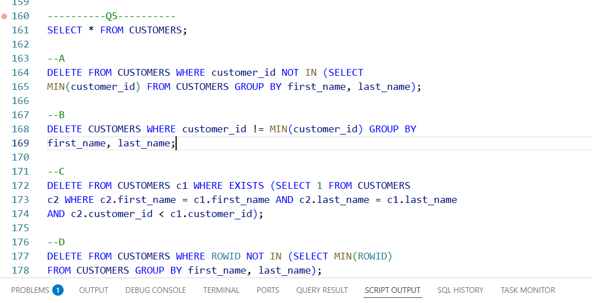

A: Correct but not handle in NULL.

B: Incorrect. B is invalid syntax.

C: Correct. Best one. This checks with EXISTS whether there is more than one person whose first_name and last_name are the same.

D: Incorrect. D keeps lowest ROWID, not lowest customer_id, so it does not meet the requirement.

Q6.
Answer is A.

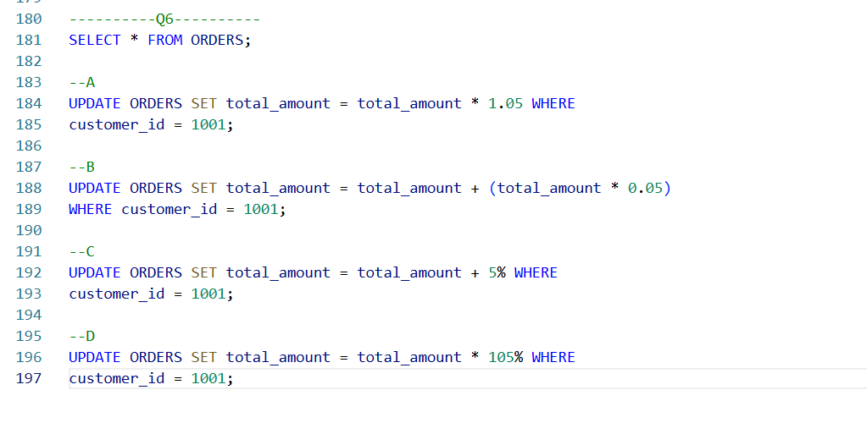

A: Correct. This is the simplest, standard way.

B: Also correct but Slightly longer syntax.

C: Incorrect. SQL does not understand 5% as a literal value.

D: Incorrect. SQL does not recognize 105% as a valid numeric literal.

Q7.
Answer is D.

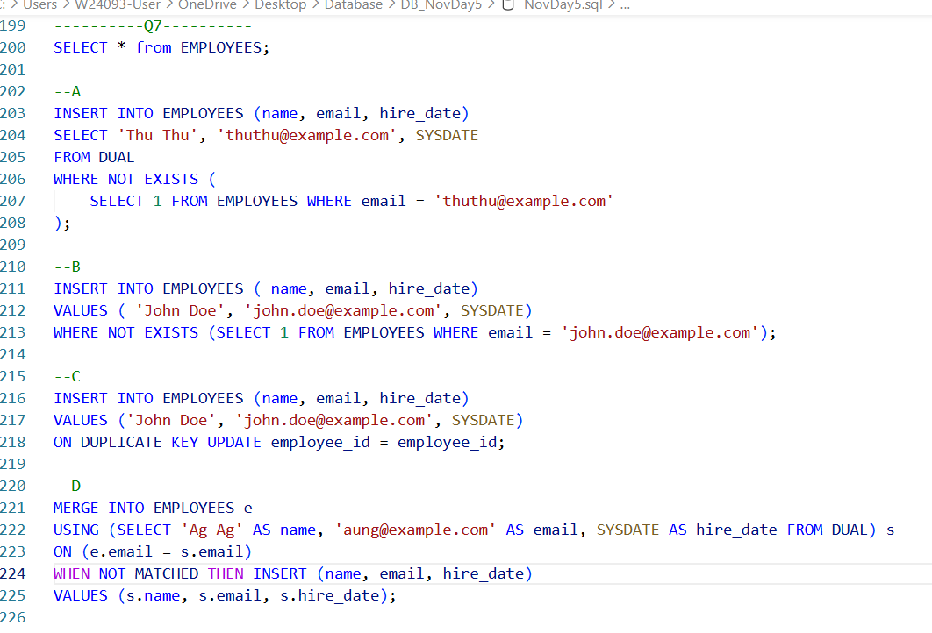

A: Correct.
SELECT … FROM DUAL WHERE NOT EXISTS (…) will return one row only if the email doesn’t already exist.
INSERT INTO … SELECT … inserts that row.
If the email exists, NOT EXISTS fails → no row is inserted.

B: Incorrect. You cannot use WHERE with VALUES in standard SQL.

C: Incorrect. ON DUPLICATE KEY UPDATE is MySQL syntax, not valid in Oracle.

D: Also correct. Can handle more complex logic. Work for both insert and update.

Q8.
Answer is B.

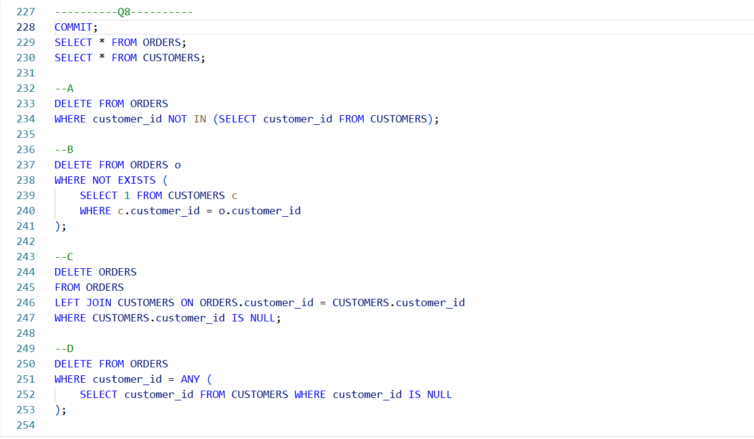

A: Incorrect. Works only if CUSTOMERS.customer_id is NOT NULL;

B: Correct.
NOT EXISTS is NULL-safe — works even if CUSTOMER customer_id contains NULLs.
Only deletes orders that truly have no matching customer.

C: Incorrect. This syntax is not valid in Oracle.

D: Incorrect. It is delete customer is null.

